Project Title: AI Study Buddy

Introduction
AI Study Buddy is an AI-based learning assistant designed to help students in their studies. It provides useful study support and helps students understand topics in an easy and simple way.
Screenshots
- Running the Backend Server in VS Code
The backend application is first started using Visual Studio Code. The required Node.js packages are installed using the "npm install" command. After installing the dependencies, the backend server is started using the "npm start" command.

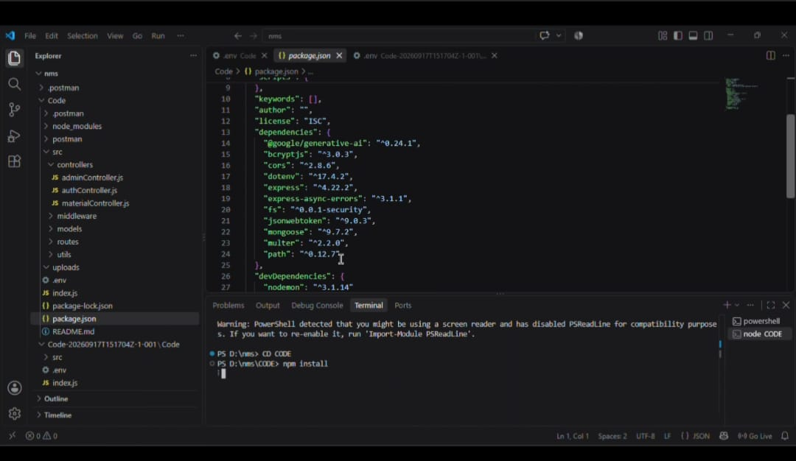
The project uses Nodemon to run the server. When the server starts successfully, it runs the "server.js" file and waits for API requests. The backend application runs on port 5000.

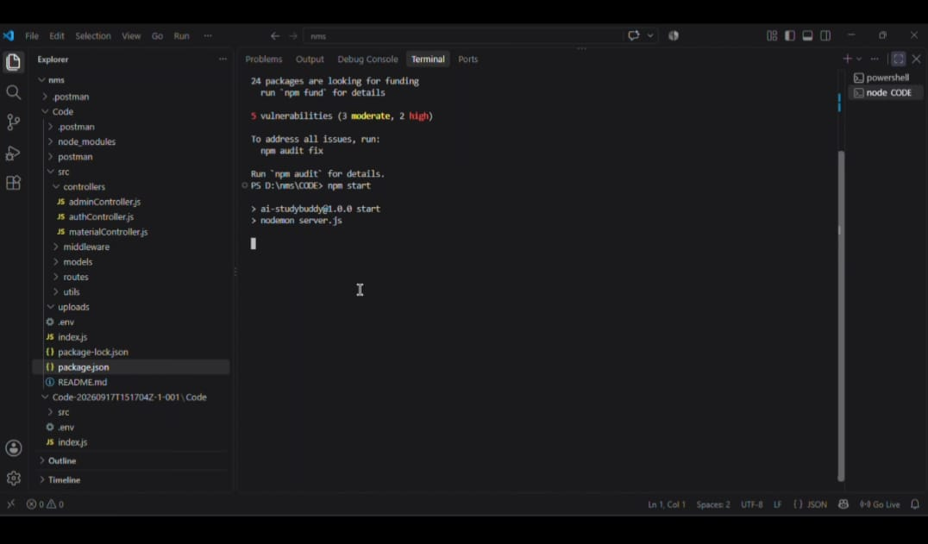
This step confirms that the backend server is running successfully and is ready for API testing using Postman.
- Student Registration
After starting the backend server, the Register API is tested using Postman.
A POST request is sent to the following API endpoint:
"http://localhost:5000/api/auth/register"
The request contains the student's name, email, password, and role. The student name is entered as Pooja, and the role is set as student.
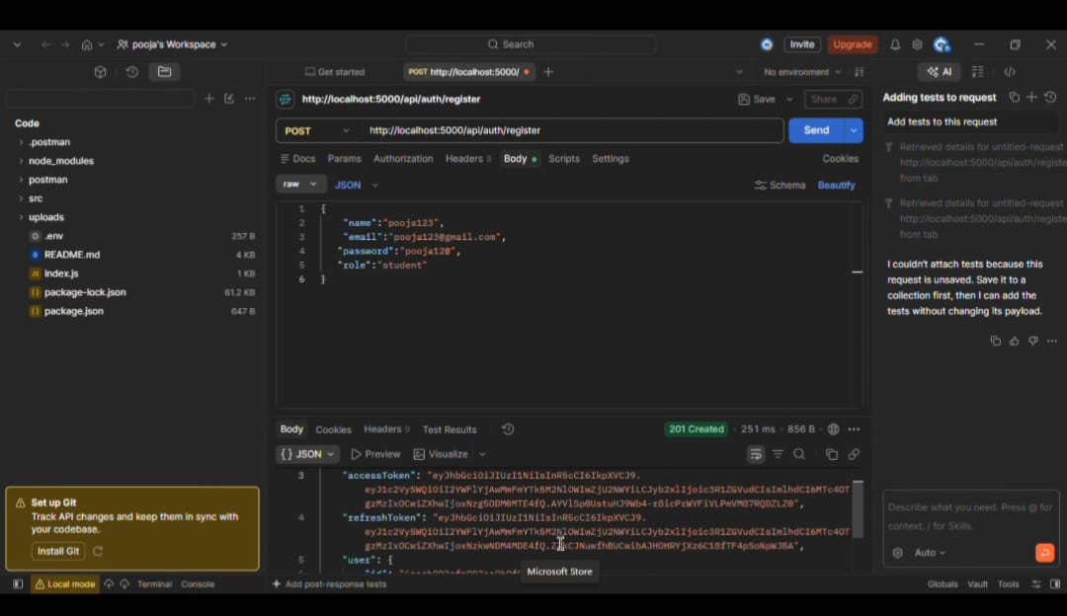
After clicking the Send button, the server processes the registration request. The response shows 201 Created and the message "Registered successfully". The response also contains the access token, refresh token, and registered user details.
This confirms that a new student account has been successfully created in the system.
- Student Login
After successful registration, the Login API is tested using Postman.
"http://localhost:5000/api/auth/login"
The registered student's email address and password are provided in the request body. After clicking the Send button, the server verifies the login details.

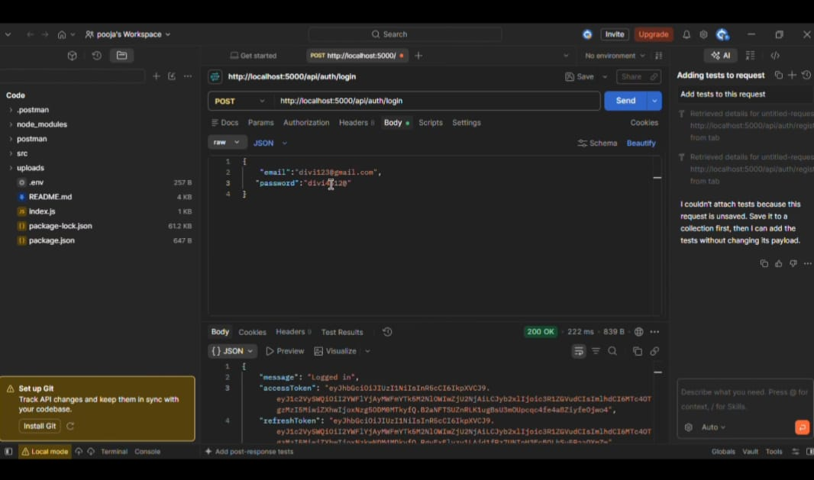
The response shows 200 OK with the message "Logged in". It also returns an access token and refresh token.
This confirms that the registered student can successfully log in to the application using valid credentials.
- Student Logout
After completing the login process, the Logout API is tested.
"http://localhost:5000/api/auth/logout"
The required user details are provided and the Send button is clicked. The server processes the logout request successfully.
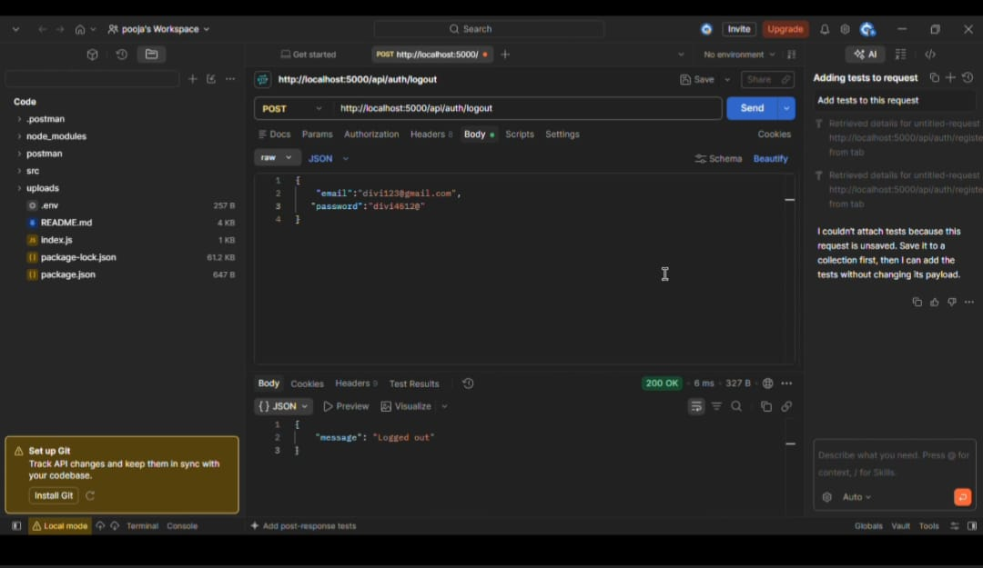
The response shows 200 OK with the message "Logged out".
This confirms that the logout functionality is working correctly and the user can successfully end the current session.
- Admin Registration
Next, an administrator account is created using the Register API.
"http://localhost:5000/api/auth/register"
The request contains the admin name, email, password, and role. The role is changed from student to admin.
After clicking the Send button, the server successfully creates the administrator account. The response shows 201 Created and the message "Registered successfully".
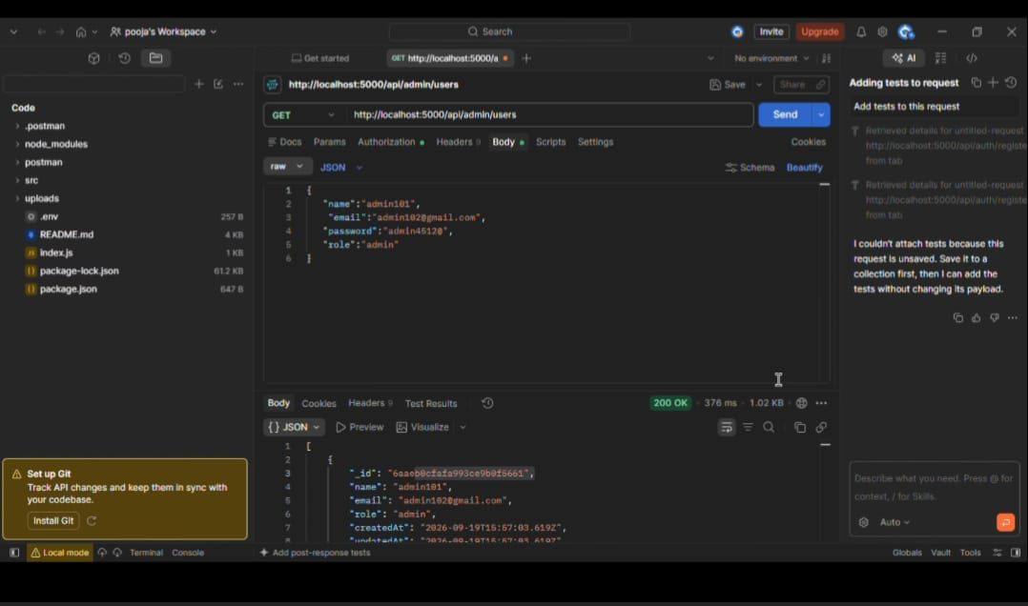
The response also provides the authentication tokens and administrator details.
This confirms that the system supports different user roles, such as student and admin.
- Deleting Student Registration
The DELETE operation is used to remove a registered student from the system. In Postman, the DELETE API request is sent with the student’s unique ID.
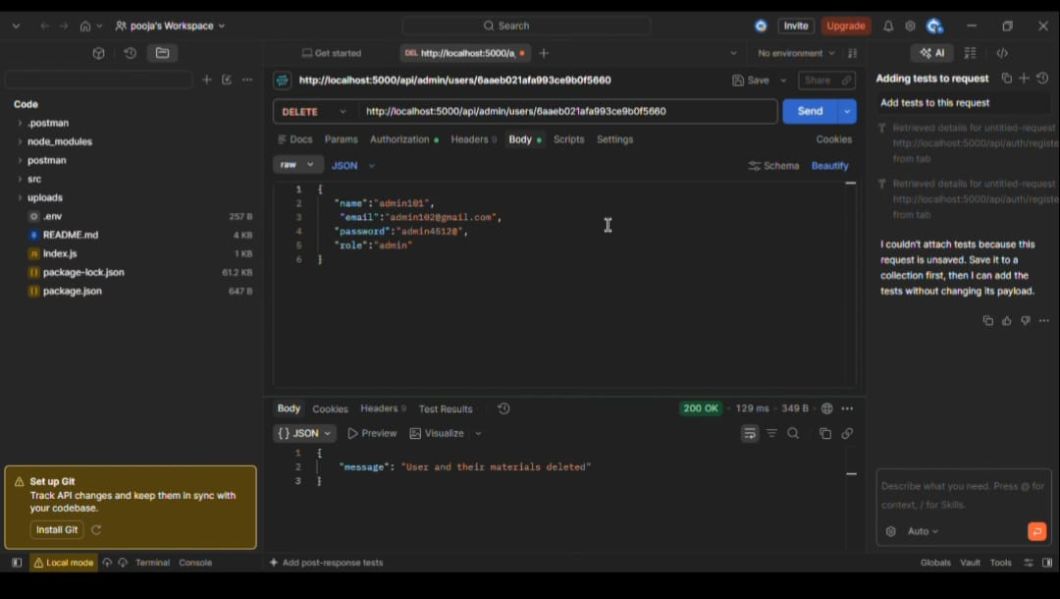
The selected student and related data are deleted from the database.A success message is displayed after the deletion.
- MongoDB Connection
The MongoDB database is now successfully connected to the project.
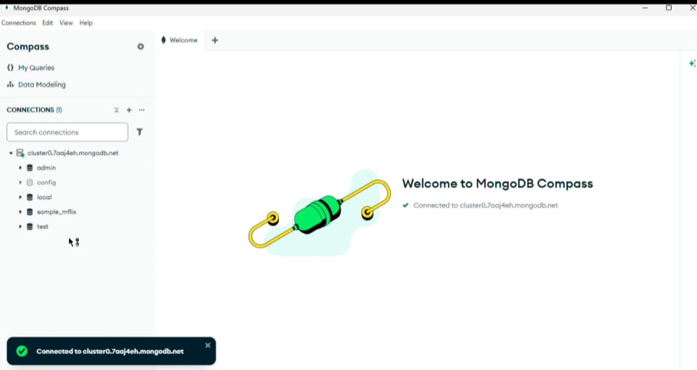
This connection allows the application to store important data like registered users and study materials. You can open MongoDB Compass to view the database and check the users collection.
- Viewing Registered Users
Using MongoDB Compass, we can easily view the registered users stored in the database. After opening the users collection, all registered user details can be viewed as separate documents.Each document represents one registered user.The details such as name, email, role, and unique user ID can be checked from the collection.
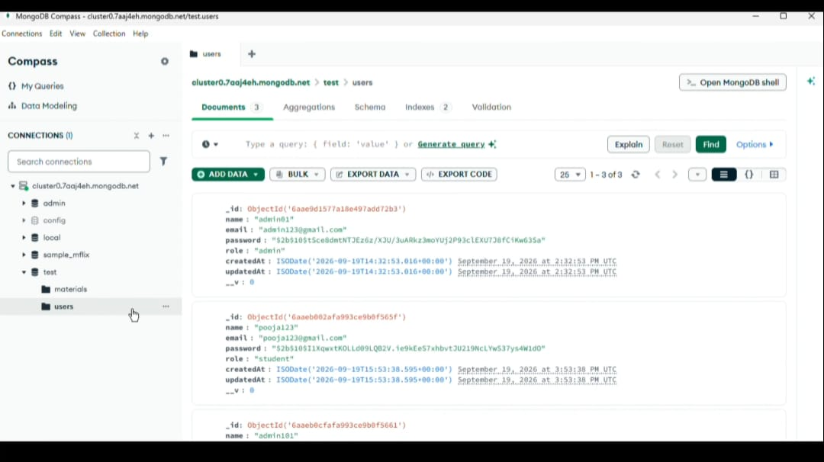

Therefore, we can use MongoDB to store, manage, and view the registered users of the AI StudyBuddy application.

